Stewardship for the Self: Mental Health, Self Care, and
Wellness Strategies for First Year Bobcats
Learning Objectives:
Students will gain an understanding of the importance of self-care and maintenance and be able to define the different dimensions of wellness in relation to the concept of self-stewardship. Students will walk away with examples of habits they can incorporate into their life on campus to maximize wellbeing and prevent/manage mental health issues.

Delivery (Presentation Notes):
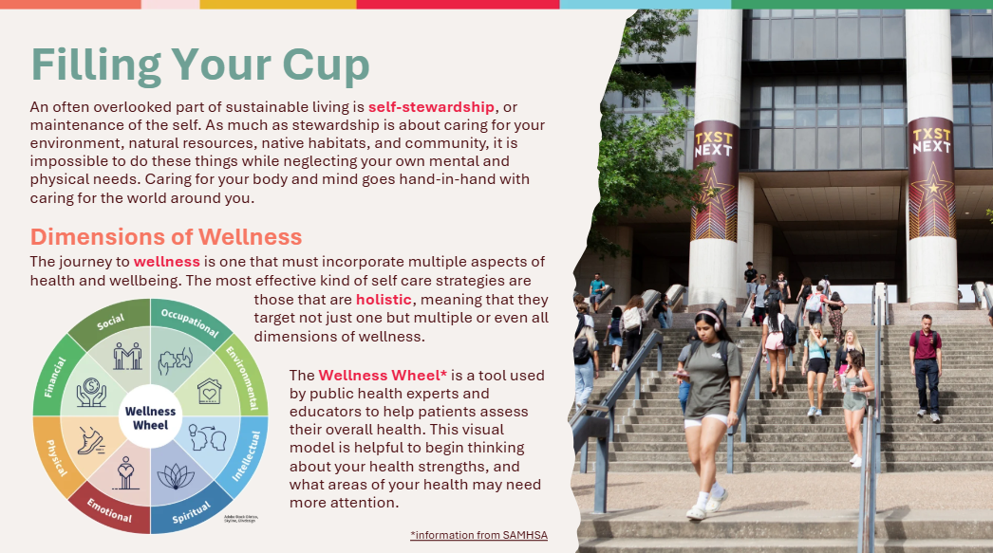 | Filling Your Cup  The presentation begins with a definition of self-stewardship as the act of caring and maintaining the self. Though it is not written into the slide, instructors should point out that self-stewardship requires the maintenance of personal wellbeing on multiple dimensions, which are illustrated by the Wellness Wheel diagram in the bottom left corner. It is not necessary to delve into the details of each, only to emphasize that wellness does not look like one thing, and therefore self-stewardship is not only one kind of practice but must target many types of wellness to ensure holistic care. Connect the maintenance of self with care for the environment, because we as humans are not separate from the world but part of it.
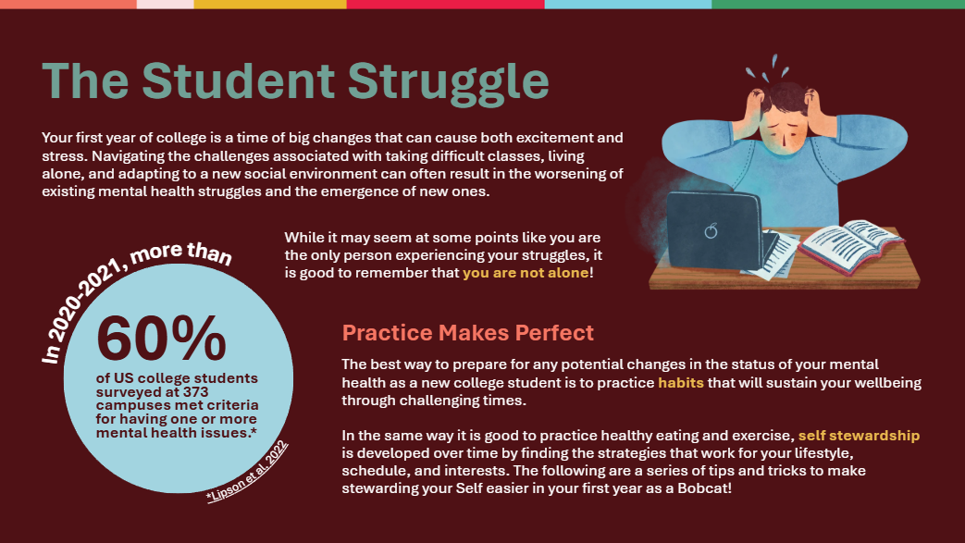 | The Student Struggle  The goal of this slide is to contextualize the need for self-stewardship amongst college students specifically. Instructors should highlight how mental health struggles are extraordinarily common amongst American college students, dispelling any shame that might be associated with these challenges. This slide provides a transition to the following ones by referencing the self care habits that will be discussed in the rest of the presentation.
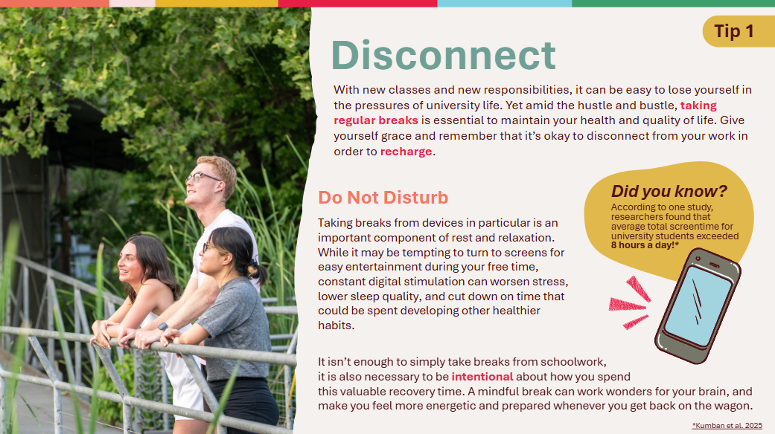 | Tip 1: Disconnect  The word “disconnect” serves a double meaning in the context of this recommendation, meaning both to figuratively disconnect from responsibilities and also literally disconnect from digital device usage. Essentially, this tip drives home the importance of taking breaks from stressors in order to ultimately produce better work and maintain long term energy levels. The final paragraph is the most important part of the slide, which states that it is not enough to simply take breaks, but to be intentional about how break time is spent (and not potentially squandering it on other unhealthy behaviors like excess screentime).
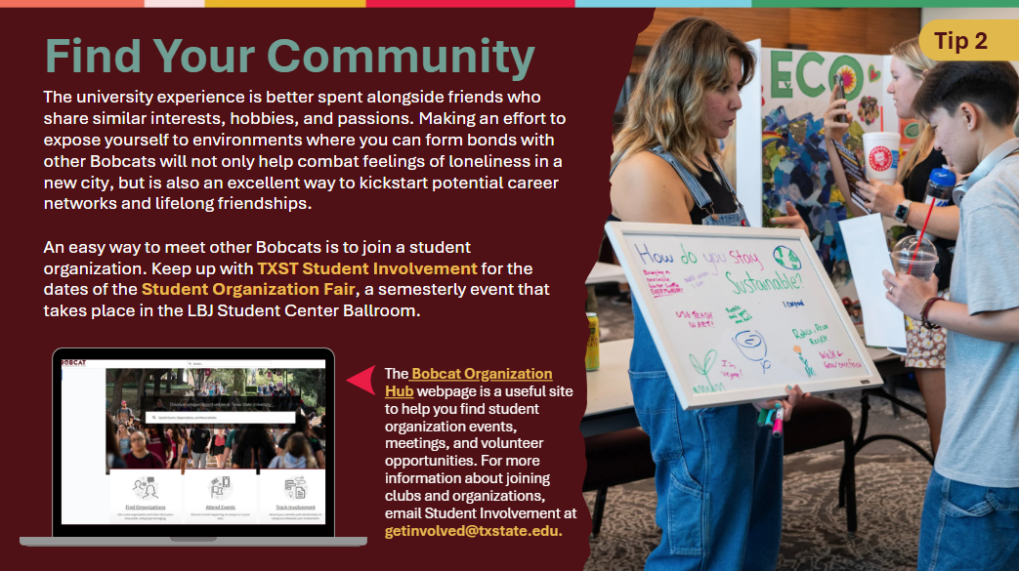 | Find Your Community  This second tip is listed after the first because it can be an example of how to spend intentional rest time, that being in community with other Bobcats. Although there are many ways to go about forming community, this slide proposes the easiest method for Bobcats living on campus, that being to join student organizations. Instructors should emphasize that student organizations are not only places to form career networks and acquire resume experience, but also places where many Bobcats make lifelong friends. Whether students are interested in crafting, sports, media, or activism, they can encounter all of these interests and more by attending the Fall and Spring Student Organization Fair, or by browsing the Bobcat Organization Hub website, which is linked in the bottom paragraph.
Get Outside

This is the first of three slides that promote the message of the TXST Campus Nature Rx program, which aims to help students incorporate time in nature in their campus lives to reinforce wellbeing and mental health. The tip is divided into four subsections, focusing each on how students can participate in Outdoor Habits, Outdoor Locations, Outdoor Courses, and Outdoor Events to maximize time spent in nature. The Outdoor Events subsection in particular features four clickable links to each event’s website, most of which feature the next official dates if instructors are interested in having students add them to their calendars. Outdoor Locations also features clickable links for instructors to show the programming and activities available at each site.

 | Get Outside (cont.)
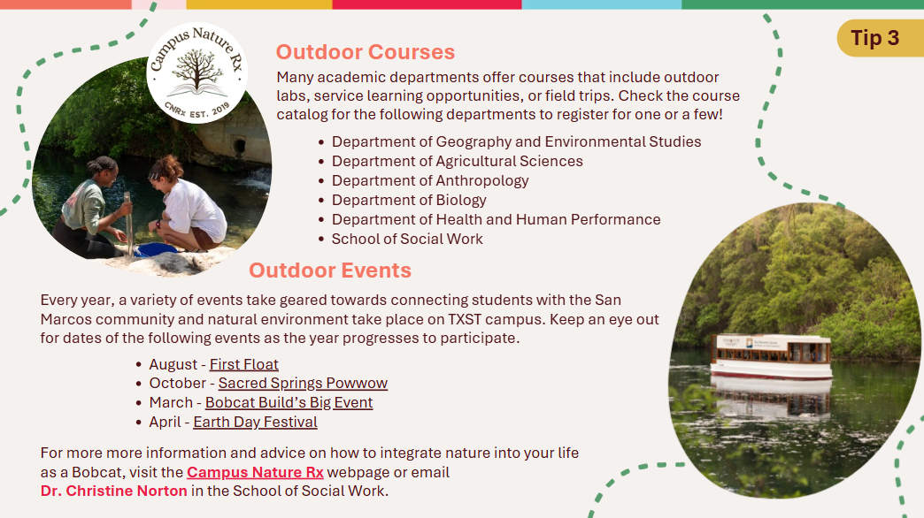 | Get Outside (cont.)
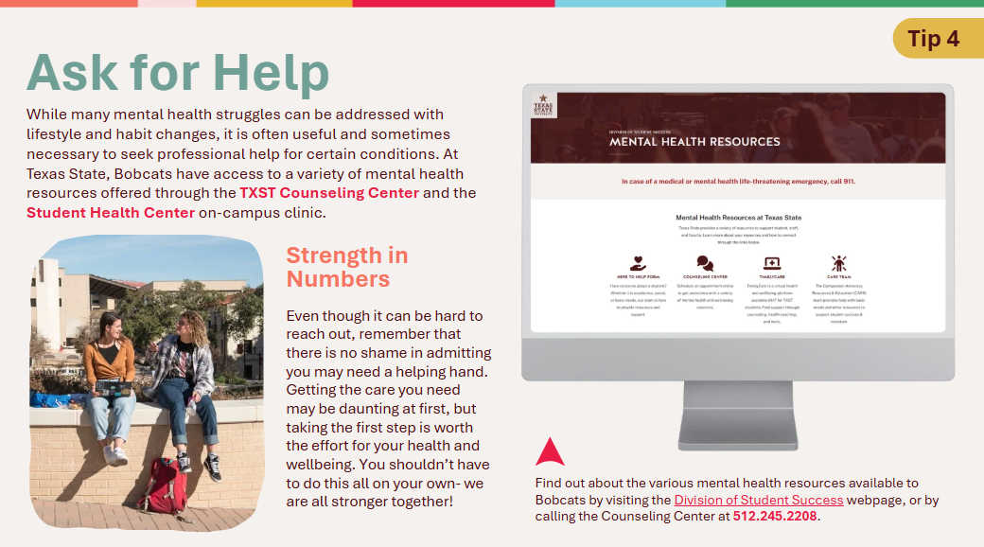 | Ask for Help  This slide was strategically placed as the last tip as a sort of underlying piece of advice. It is less of a “last resort” and more of an acknowledgement that students should engage in the other habits with the understanding that sometimes mental health struggles can only be fully addressed by professional help in conjunction with lifestyle changes. It is highly recommended that instructors show students how to navigate the websites for the TXST Counseling Center and the Student Health Center. In particular, students should be shown the online appointment making option which is offered on both sites, since many might be afraid to speak to a person over a phone call to receive help. Instructors should make clear that each service is completely confidential (parents need not know) and that there is no shame in reaching out if students are in an intolerable mental or physical health situation.
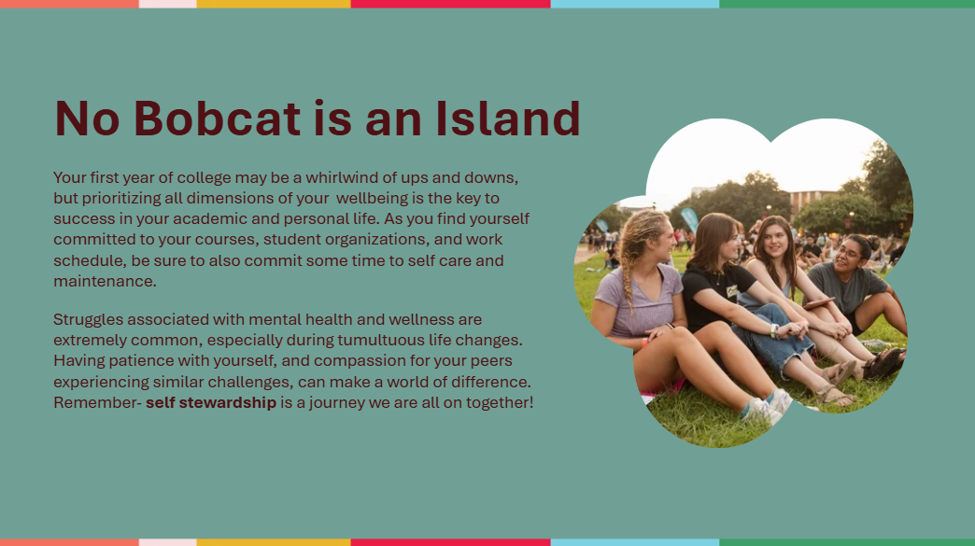 | No Bobcat is an Island  The presentation concludes with a reiteration of the message that students are not alone in their self stewardship journey, as it is one that everyone must engage with throughout their lives. Instructors should leave students with a sense that as much as the first year of university will demand much from students academically, they must also be sure to avoid neglecting the needs of their personal and internal lives.

Activity: Wellness Wheel Self-Assessment
Materials needed for this activity will be printouts of the Wellness Wheel Worksheet packet (enough for one copy per student), and colored pencils, crayons, or markers. Instructors may have a class set of coloring utensils and/or have students provide their own and share.
The objective of this activity is to have students evaluate the status of their wellness in each of the eight dimensions outlined in the Wellness Wheel, and rank each area on a scale of 1-5.
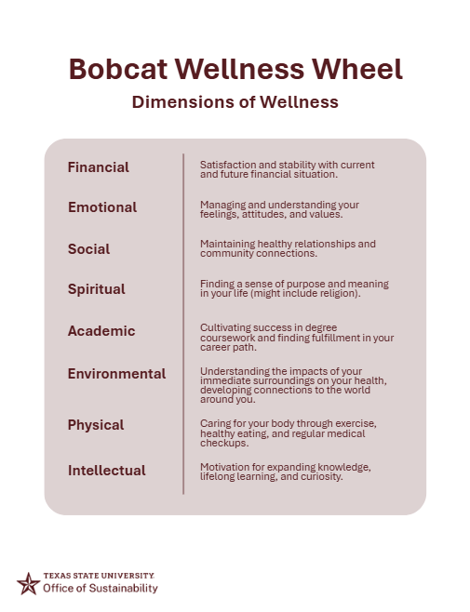
Along with the wheel itself, the worksheet package features a detailed outline of the definition for each dimension of wellness (Figure 1), which instructors may go through with students as a class. Instructors may want to give examples for a few of the dimensions to ensure that students understand what qualifies as each. For instance, examples of financial wellness might include the ability to afford groceries, credit score, or amount of money in a checking account. Indicators of social wellness might include number or quality of friends, feeling of connection versus isolation from a community, or willingness to interact with strangers.
Figure 1
After answering any clarifying questions about the different dimensions, instruct students to color their Wellness Wheels according to the rank that they assigned each dimension, referencing the scale included in the bottom right corner of their worksheet (Figure 2). The more students feel satisfied about a given dimension of their wellness, the more rings they should shade in that corresponding slice of their wheel, and vice versa. This is best done in color for visual stimulation, but can also be done with regular pencil to the same effect.
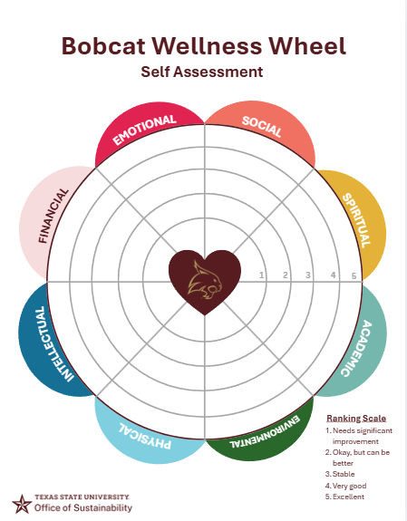
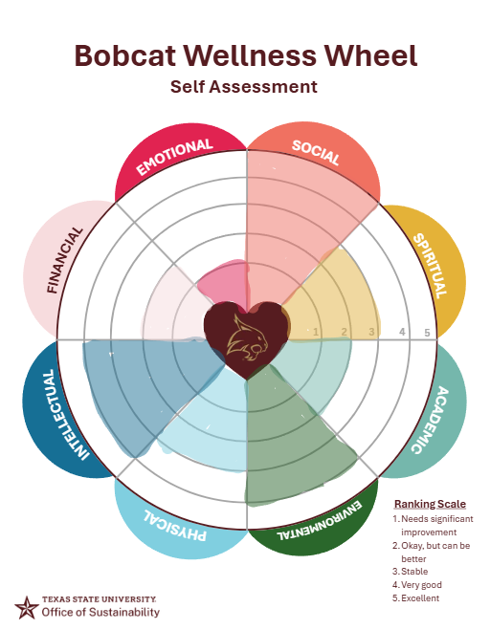
Figure 2

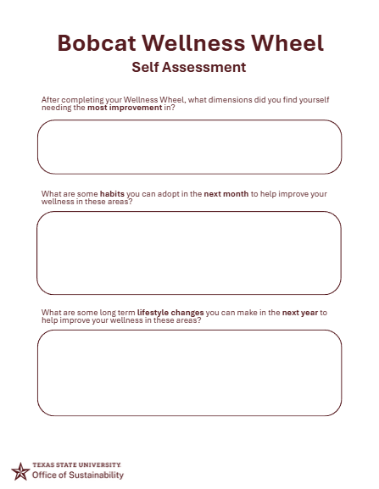
After students finish shading their Wheels, the second page in the worksheet packet asks three follow up questions about how students ranked each dimension of wellness (Figure 3). These questions ask students to reflect on what dimensions need the most attention, and what changes can be made in their lifestyles over both the short and long term to accomplish these improvements.
Figure 3
This portion of the activity can either be done individually, or as part of a group discussion in a sort of “Think, Pair, Share” fashion. Either way, this portion of the activity is the core component of the lesson and should be included in some shape or form, as the goal is to have students to critically reflect on their lifestyle and walk away with achievable improvements that could benefit their wellness.
BONUS COMPONENT: If instructors wish, they may turn this activity into a homework assignment by asking students to try implementing one of the strategies they brainstormed in the self-assessment follow up questions. To grade, instructors can have students write a short reflection of their experience trying this strategy, and reviewing how the habit may or may not have improved the targeted dimension of their wellness.

