Sustainability 101 Lesson Plan
Learning Objectives:
Students will understand the broad purpose and basic tenets of sustainability as a concept, and the five main ways that Bobcats can engage in sustainable living and practices as a first-year student. Students will also be introduced to the resources provided by the Office of Sustainability on TXST campus.

Delivery (Presentation Notes):
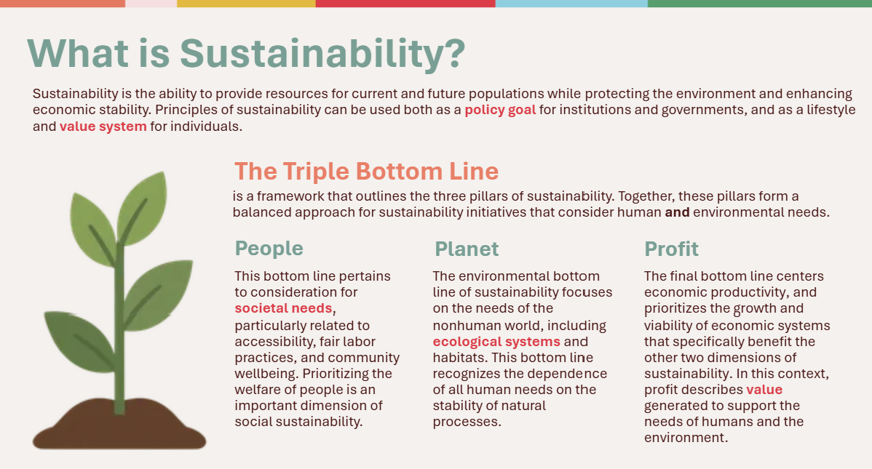 | What is Sustainability?  This slide serves as students first exposure to the sustainability framework, which revolves around the three pillars of people, planet, and profit. Explain to students that while sustainability is a guiding framework for institutions like universities, it is also a value system that can be applied to individual habits and lifestyle choices. Explain that while institutions like governments, businesses, and schools can create policies to make their operations more sustainable, it is only through a collective shift in the everyday decision-making of people that sustainability can become a lasting and sustained movement.
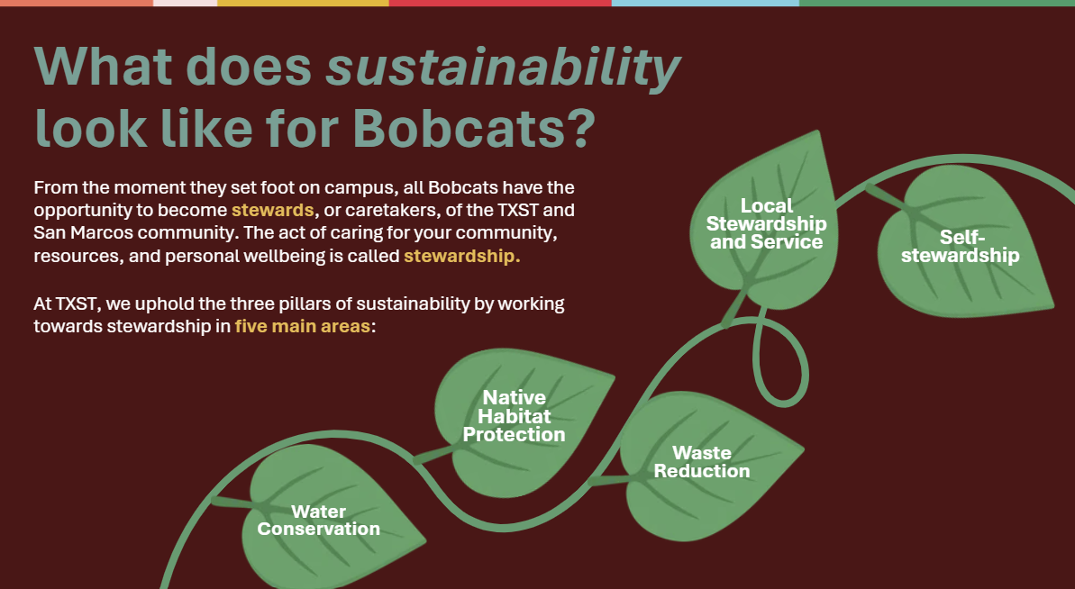 | What does sustainability look like for Bobcats?  Whereas the previous slide explains the pillars of sustainability as a broad concept, this slide introduces the five areas of stewardship that make a sustainable Bobcat. These include water conservation, native habitat protection, waste reduction, local stewardship and service, and self stewardship. Explain to students that if sustainability is the overarching goal or guiding value to preserve resources for future generations, stewardship is the practical means of achieving said goal. These five areas of stewardship were chosen to highlight how sustainability intersects with the specific needs of the TXST and San Marcos human and nonhuman environment.
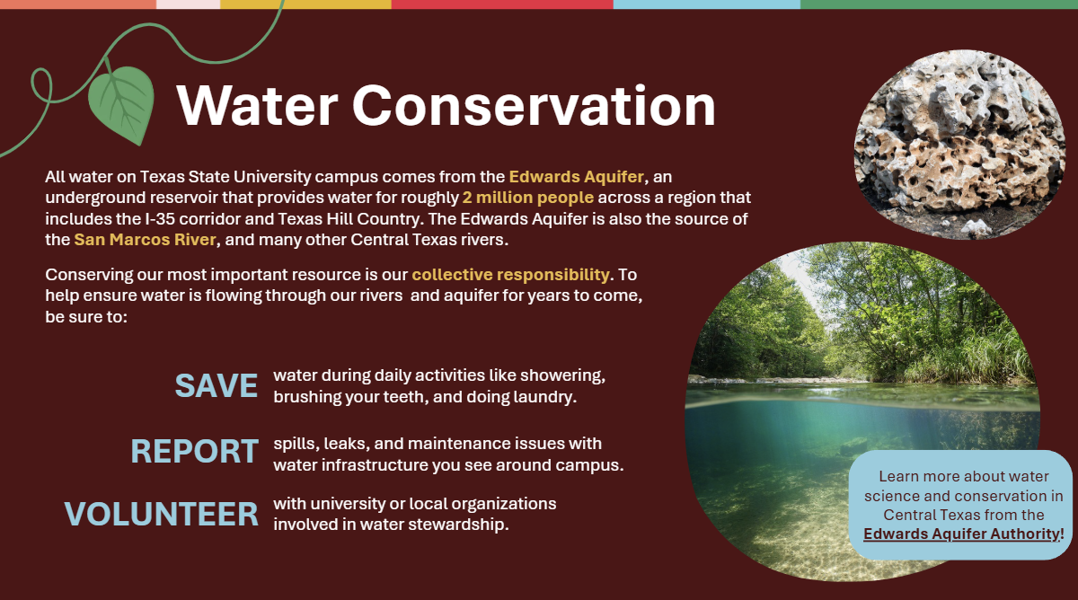 | Water Conservation  At TXST, sustainability begins with water conservation because of the way that San Marcos relies on the unique hydrogeology of the Edwards Aquifer. Connect information on this slide to the personal experiences of students, who have by this point in their college experience likely made a visit to the San Marcos River and seen for themselves how water moves from the aquifer, even if they were not aware of it at the time. Explain that even though it may look like water is abundant in the region, the geologic reason that the river is flowing is the same reason that water is constantly leaving the aquifer naturally and as a result of human behavior. Conserving this water is important to ensure rivers will continue flowing and water will be available for human consumption for generations to come.
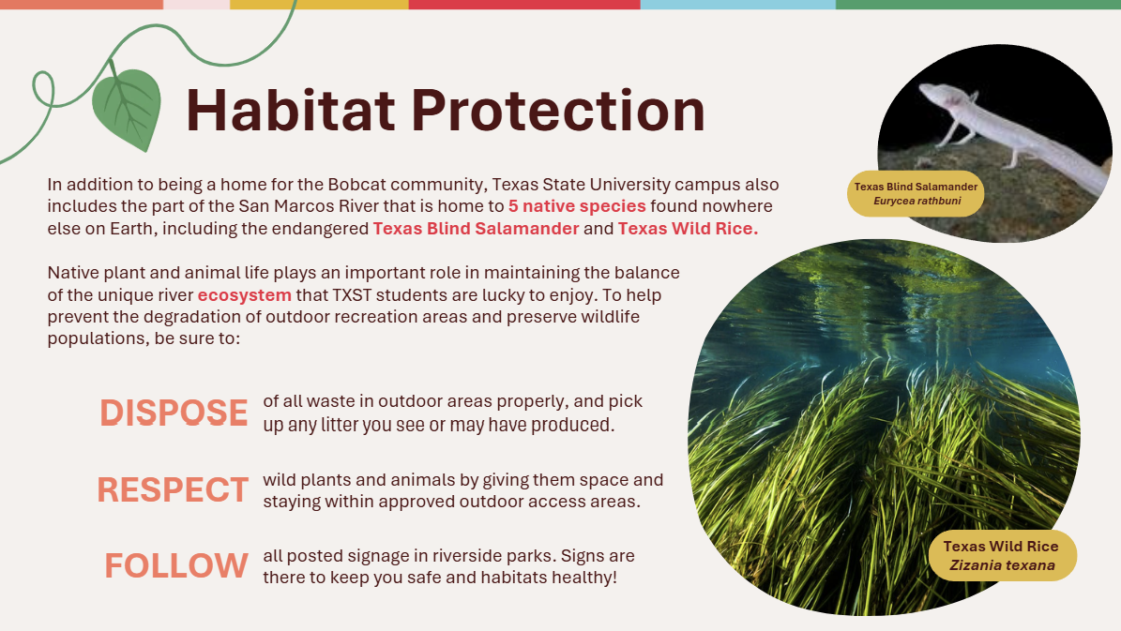 | Habitat Protection  Closely linked to water conservation is the conservation of native habitat, which the San Marcos river provides for five important endemic species. These species are listed by the federal government as endangered, meaning they are at risk of extinction, or threatened, meaning that they are not currently at risk of extinction but are likely to be in the near future. Explain that the delicate balance of the San Marcos aquatic ecosystem is what keeps the river a refuge for humans and animals alike, emphasizing that as students become settled in their new home they must recognize that they share space with a vibrant community of flora and fauna. It is also worth emphasizing that the San Marcos community is centered around its natural environment, and its preservation is thus a deeply engrained part of local culture.
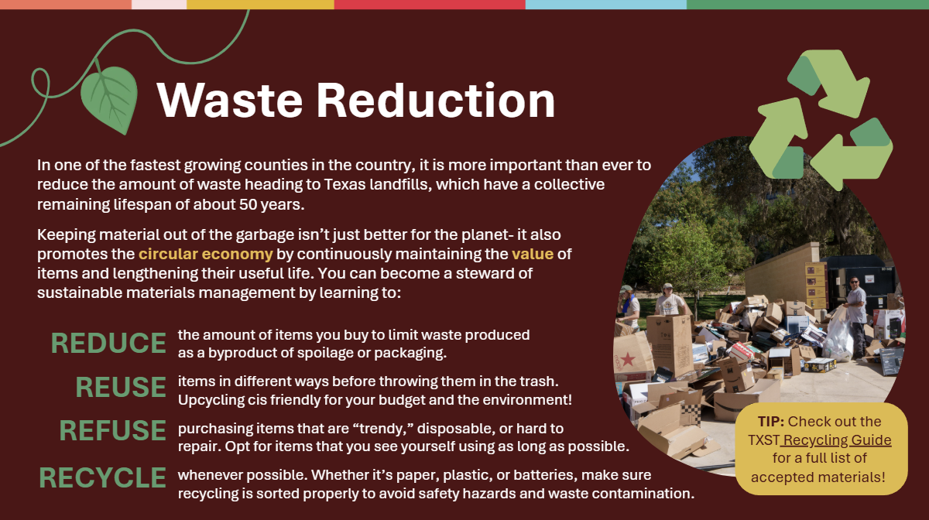 | Waste Reduction  This slide addresses what is likely the most familiar aspect of sustainable stewardship to students, as most by this point have been exposed to “The 3 R’s.” Using this prior knowledge as a reference point, explain that practicing waste reduction is about more than simply recycling, but also limiting the consumptive practices that lead to the production of waste in the first place. Especially as students view the cycle of trendy clothing and products on social media, emphasize that much of waste reduction actually comes down to avoiding purchases that ultimately strain landfill space, natural resources, and their own finances. For campus specific information about how to approach disposal of different kinds of materials, consider also navigating to the TXST Recycling guide accessible via the clickable link in the yellow bubble on this slide as well.
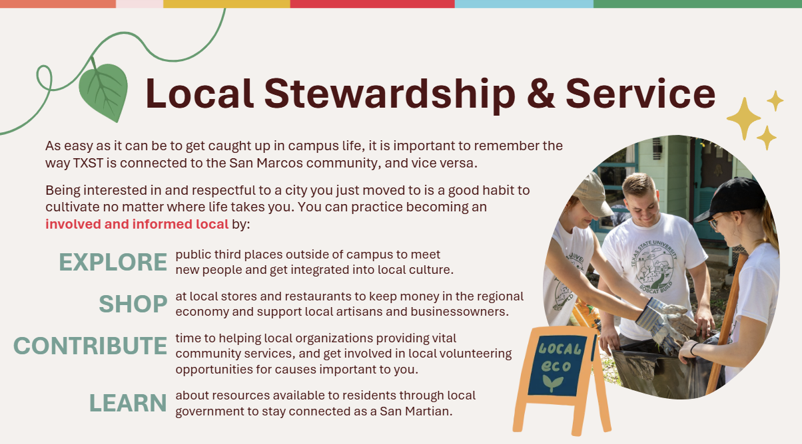 | Local Stewardship and Service  Though local stewardship might seem to be a nebulous concept at first, at the root of this kind of stewardship is the practice of being respectful and considerate towards local culture, residents, and businesses. Explain to students that it is important to remain aware throughout their time at TXST that the university is not a separate entity from the greater San Marcos community, but is in fact inherently connected to and reliant on it. Encourage students to become “good locals” by exploring local shopping districts, art scenes, music events, and public gathering spaces to familiarize themselves with the parts of San Marcos that exist outside of the university. Ask that they remember how their actions do not only impact other students, but also to the thousands of people that call San Marcos home. Emphasize also that this is a skill which can follow them wherever they move after they graduate, as being a good local can help them develop community, support networks, and geographic knowledge no matter where they live.
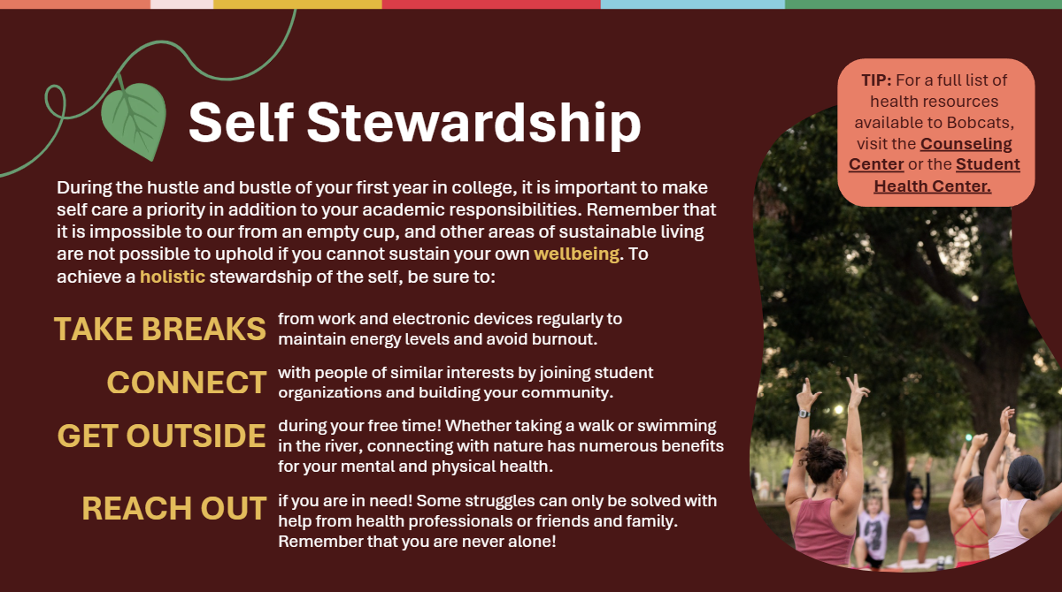 | Self-Stewardship  The final type of stewardship associated with sustainable living as a Bobcat is care and maintenance of the self, which comprises of physical, mental, and spiritual health. It may be useful to introduce this concept using the popular saying, “You cannot pour from an empty cup,” as it describes the necessity of self-care as an extension of community and environmental care. In addition to featuring pieces of advice for students to take breaks, connect with others, get outside, and reach out for help, this slide also features two clickable links that direct to the websites for the Student Health Center and Counseling Center. It is worthwhile to show students these resources to proactively demonstrate how they can schedule appointments and access healthcare. In this way, students will already be familiar with how they can receive help should they encounter a time of personal crisis later in their academic careers.
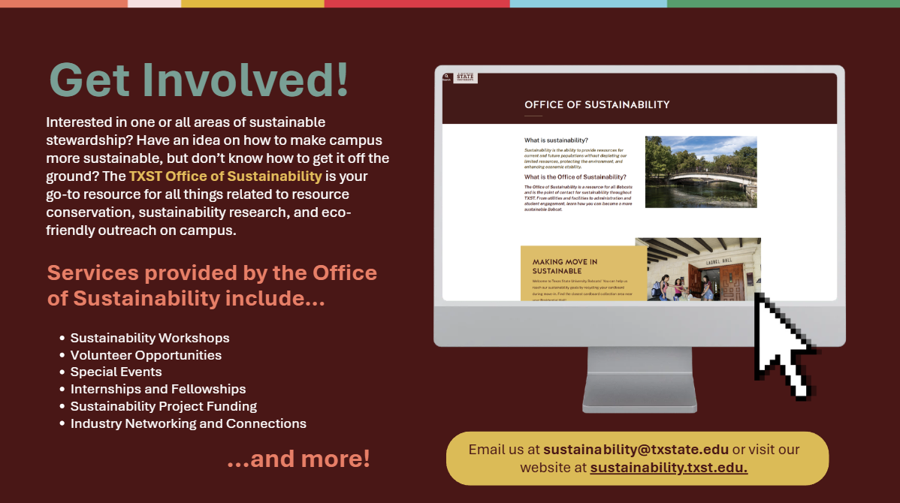 | Get Involved!  This slide introduces students to the TXST Office of Sustainability, which provides resources, information, and services to students from all departments and academic backgrounds. Emphasize that contacting the Office or participating in sustainability events is not limited to students who are studying a sustainability-related field, but that we welcome students of all majors to find their connection to sustainability through our programs.
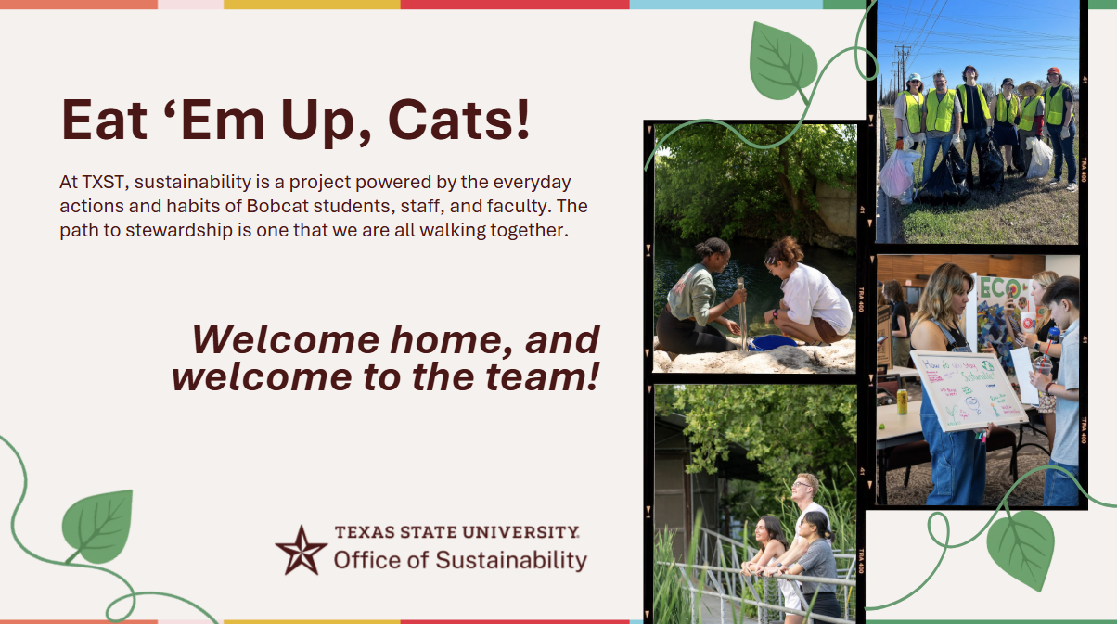 | Eat ‘Em Up, Cats!  Conclude by reiterating that sustainability is worked towards best by a community of stewardships and careholders, or people who are invested in seeing a brighter future where resources are maximized while harm to the environment is minimized. Leave students with an uplifting welcome to their new lives as Bobcats and an understanding that sustainability is more than a slogan, but rather a matter of school pride.

Activity: Be a Sustainable Bobcat!
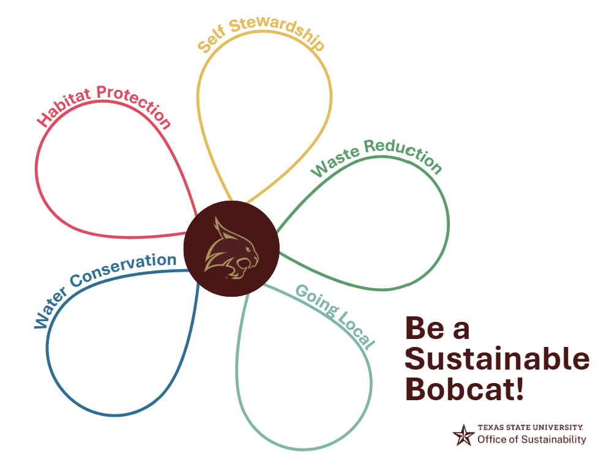
For this activity, students will need a writing instrument and a printout of the Be a Sustainable Bobcat worksheet (Figure 1).
Figure 1
Building on the idea of a multicomponent framework for sustainable living as a first year student, this activity asks students to look to their own habits for examples of each area of stewardship discussed in the presentation.
Using the slide deck as a reference guide, have students brainstorm 2-3 ways that they can practice each aspect of sustainability in their daily lives, and write it down in each petal of the model. The key is to ask students to be both specific and accessible as possible with each idea. Encourage them to think outside of what is written as a general guidance on each slide and more about the habits that they already have when it comes to their relationship with each area of sustainability. Below are a few examples of the kinds of answers students should be able to brainstorm for each area.
Water Conservation:
Taking shorter showers
Keeping a refillable pitcher of water in the fridge
Turning the tap off when brushing teeth
Washing full loads of laundry to utilize water more efficiently
Habitat Protection:
Avoid stepping on plants
Giving animals space
Keeping pets on a leash
Self-Stewardship:
Spending time with friends
Taking regular breaks from screens
Going to the doctor when feeling ill
Getting regular exercise
Going Local:
Buy from local stores
Buy groceries from in-state farms
Attend local events and markets
Waste Reduction:
Switch to a reusable water bottle or thermos
Reuse plastic bags for trash
Recycle cardboard boxes from mail deliveries
Assure students that these habits do not have to be ones they already practice, but can be changes that they can or want to make in their lifestyles to be more sustainable. Avoid accepting vague or short answers, such as “recycle” or “don’t litter.” For more specific answers, ask students to think about the locations or situations in which they would practice these habits. What materials do they encounter the most that can easily be recycled instead of thrown away, and where are they coming from? What specific places around campus are important to avoid littering in? In this way, these answers can change from one or two words to something closer to, “Recycling plastic Starbucks cups,” or “Picking up litter in riverside parks.”
In place of every student receiving a copy to work with, instructors may also conduct this activity as a group by projecting the worksheet onto a whiteboard and manually writing on it with an erasable marker. However, this activity is best completed as a “Think, Pair, Share” style, where students are given a few minutes to discuss with a neighbor before filling out their own assignment and sharing with the class in an instructor-facilitated discussion.

