How to update address information in PaymentWorks
For Individuals/ DBA’s
Please go into your PaymentWorks account at www.paymentworks.com to update your vendor information so we can process your payment and update your account. Please log in using the details below to ensure that TXST receives the updated address. If you do not have access to this account, please let me know and I will send further instructions.
How to Update or Share Remittance and Corporate Addresses:
If you or your customer identifies the need to update your Remittance Address (used for payment purposes) or Corporate Address, follow the steps outlined below. Additionally, instructions for sharing a new remittance address with your customer are included.
Important Note: Updates to remittance or corporate addresses may require customer approval, which could result in processing delays.

Part A – Updating the Remittance or Order Address
- Log in to your PaymentWorks account.
- Click on the My Payee Profile in the side navigation menu on the left.
- Scroll down to the Addresses & Bank Accounts table.
- Click on the address row you would like to update or change to expand it.
- Click Edit.
- Click Save to finalize.
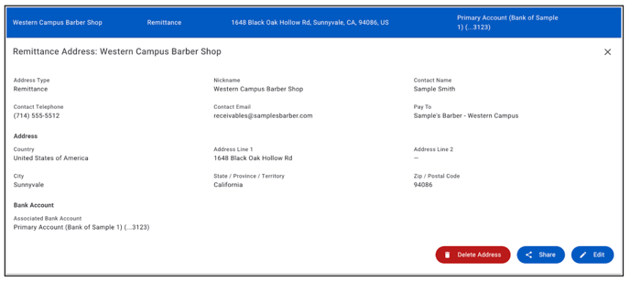

Part B – Adding Remittance or Order Address
- Log in to your PaymentWorks account.
- Click on the My Payee Profile in the side navigation menu on the left.
- Scroll down to the Addresses & Bank Accounts table.
- Click the +Add Address button on the top right of the table.
- Fill out the form and then click Add Address to finalize.
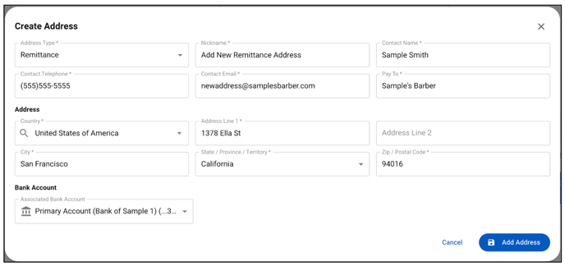

Part C – Sharing Additional Addresses
- Log in to your PaymentWorks account.
- Click on the My Payee Profile in the side navigation menu on the left.
- Scroll down to the Addresses & Bank Accounts table.
- Click on the address row you would like to update or change to expand it.
- Click Share.
- Select available customers from the Available to Share section on the left.
- Click Share, and select Texas State Univeristy.
Note: Order addresses can only be shared with customers accepting order addresses.
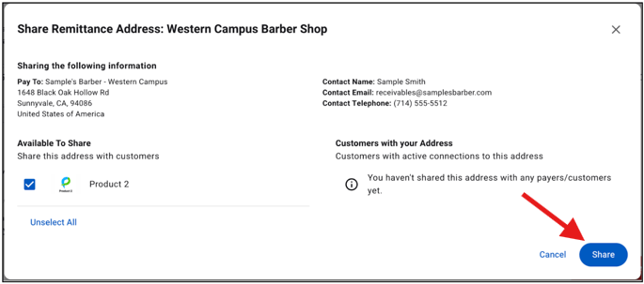

If you have questions or need assistance, please contact PaymentWorks Support.

