Canvas Analytics Shell Course/Live Course Guide
For assistance contact:
Program Accreditation and Assessment
Assistant Vice Provost for Program Accreditation and Assessment
Dr. Lon Olson – lw05@txstate.edu

Assessment Coordinator
Darius Wiley Jr – dlw185@txstate.edu
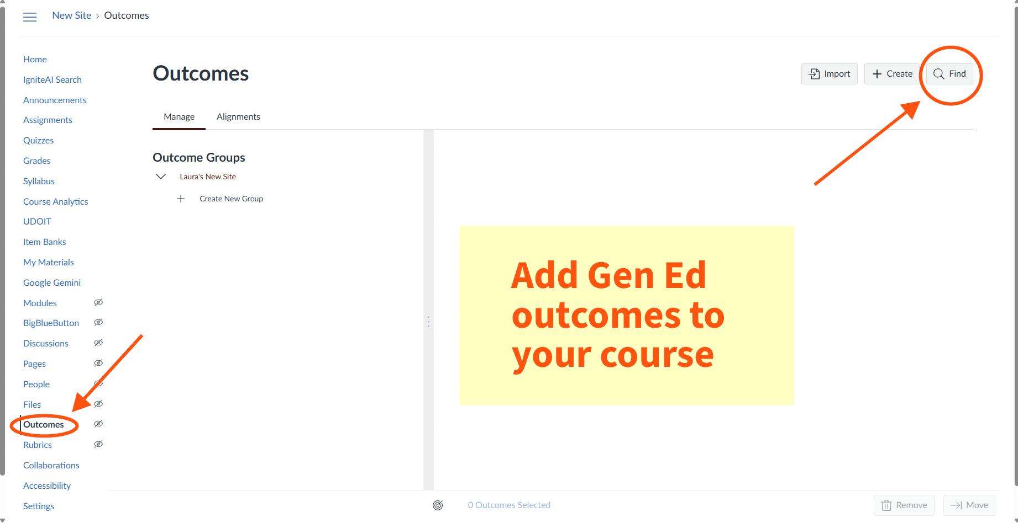

After ensuring the shell course is located at the College level, navigate to the Outcomes tab in the select course. This tab is where you will import General Education standards into the course. Click the Find tab at the top right to search for the standards.
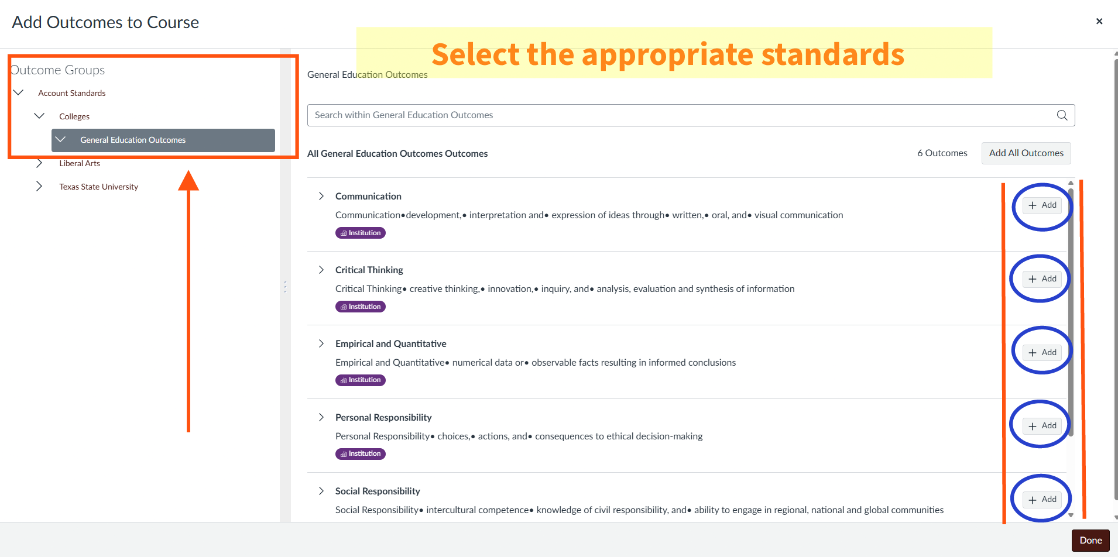

Under Outcomes Groups, select Account Standards -> Colleges -> General Education Outcomes. On the right-hand side, add the appropriate competencies for the State of Texas standard component.
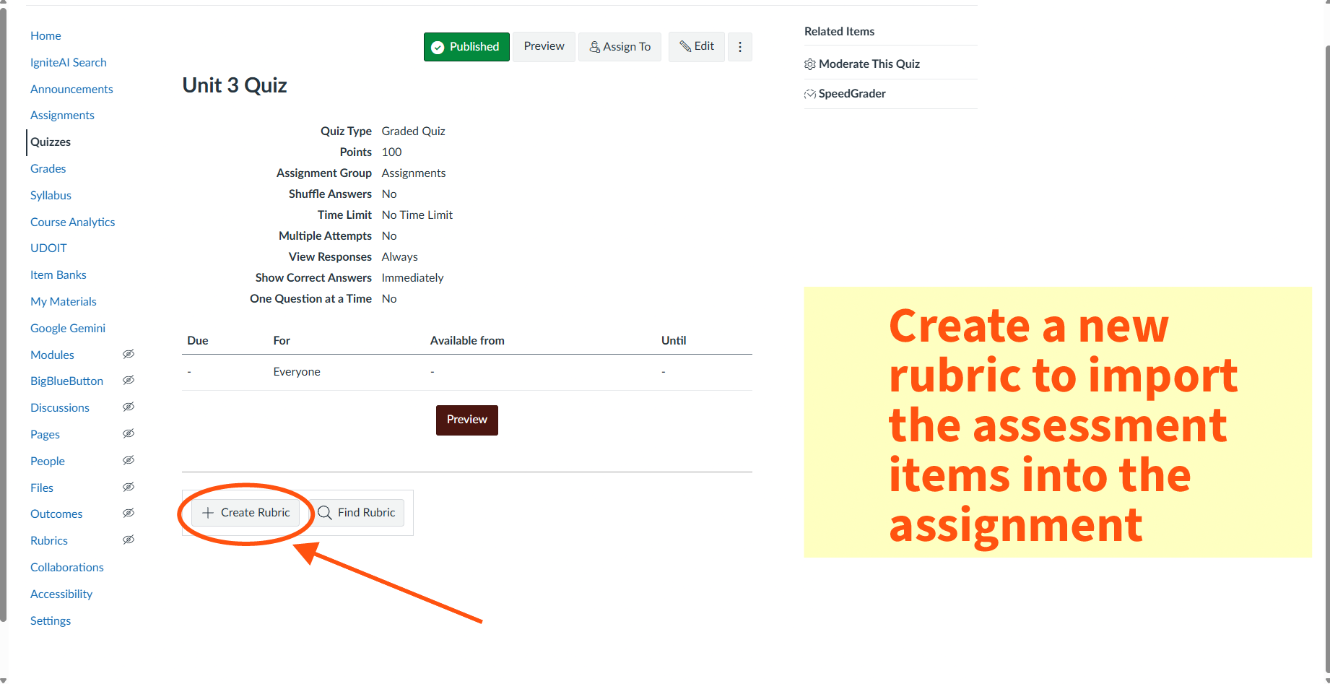

Now that the outcomes are imported into the course, navigate to the assignments tab to import the outcomes rubric into the assessment metric. Open the assignment and click “Create Rubric”.

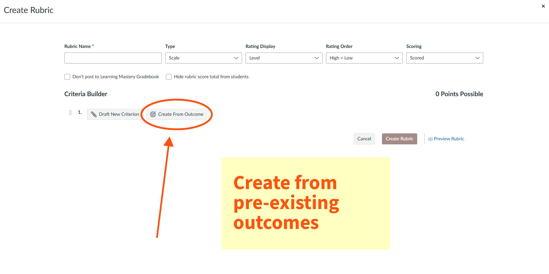

Now you can create the rubric from the outcomes that were imported into the course.
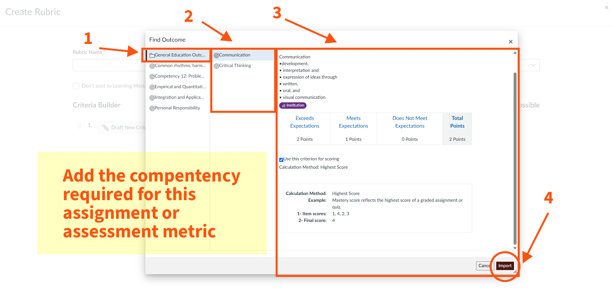

- Click General Education Outcomes
- Select the competencies required for this item
- Check to make sure you’ve selected the correct standard
- Import the outcome standard into the rubric.
- Repeat if other standards are required.
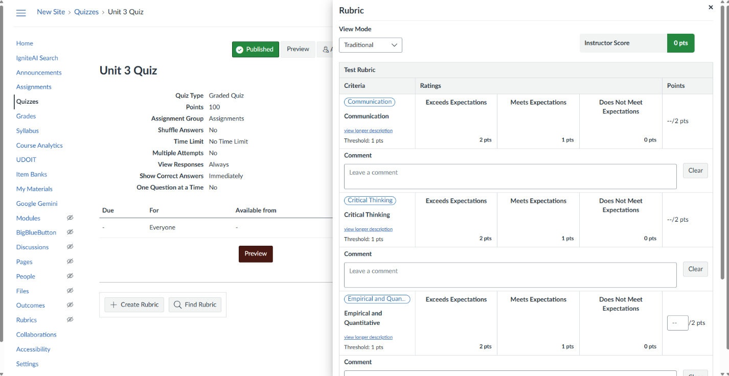

Selected competencies added to the rubric should look like the image above.
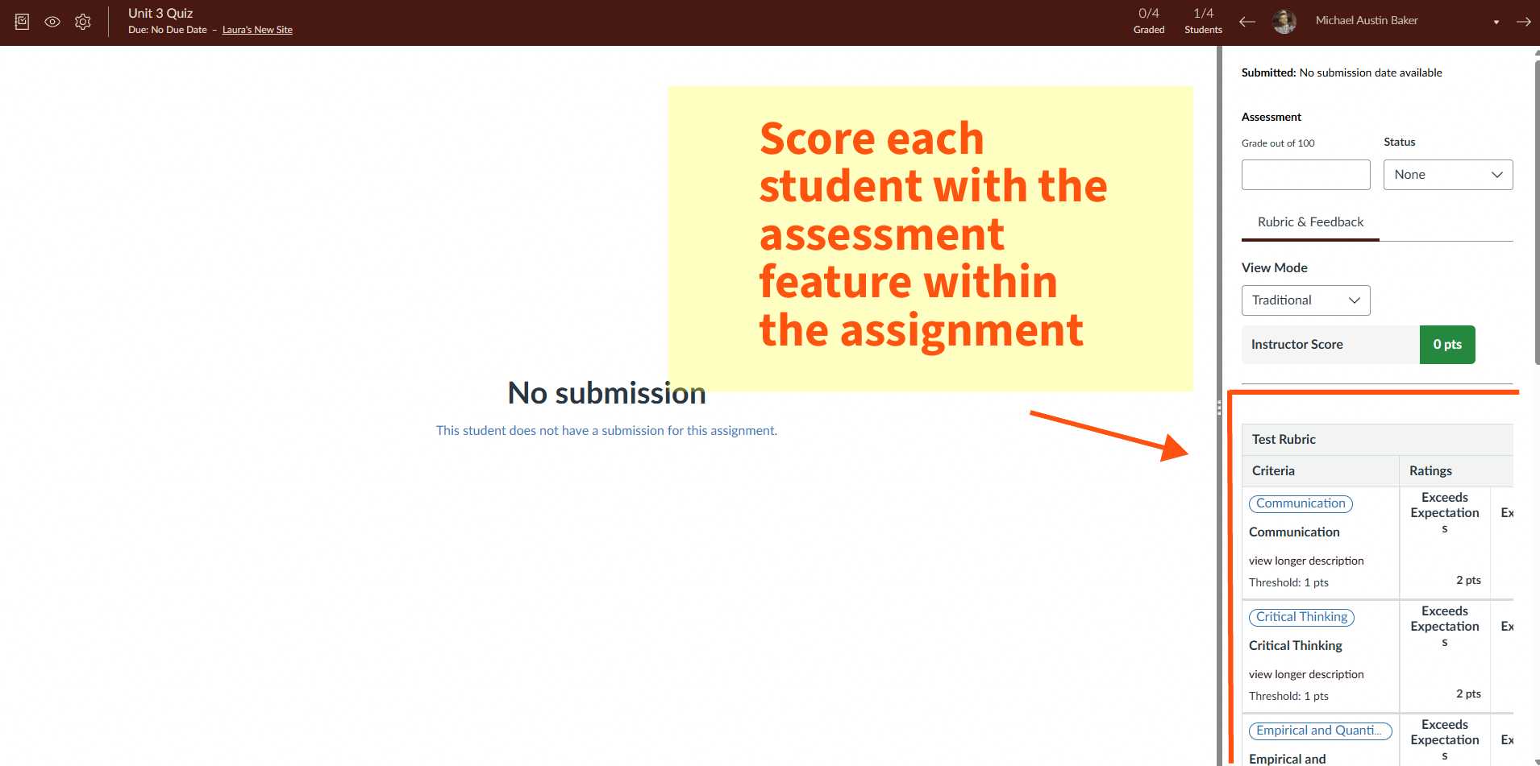

Now that your rubric is merged with your assessment items, navigate to the assignment and utilize the “speed grader” function to easily grade and assign an assessment score to each student.

